**VISVESVARAYA TECHNOLOGICAL UNIVERSITY**

**“JnanaSangama”, Belgaum -590014, Karnataka.**



**LAB REPORT**

**on**

**Object-Oriented Modelling and Design**

**20CS6PCOMD**

***Submitted by***

**RAHUL PRAKASHA (1BM18CS078)**

***in partial fulfillment for the award of the degree of***

**BACHELOR OF ENGINEERING**

***in***

**COMPUTER SCIENCE AND ENGINEERING**



**B.M.S. COLLEGE OF ENGINEERING**

**(Autonomous Institution under VTU)**

**BENGALURU-560019**

**May-2022 to July-2022**

**B. M. S. College of Engineering,**

**Bull Temple Road, Bangalore 560019**

(Affiliated To Visvesvaraya Technological University, Belgaum)

**Department of Computer Science and Engineering**



**CERTIFICATE**

This is to certify that the Lab work entitled “Object-Oriented Analysis and Design(16CS6DCOOM) Lab Record” was carried out by **RAHUL PRAKASHA (1BM18CS078),** who is a bona fide student of **B. M. S. College of Engineering.** It is in partial fulfillment for the award of **Bachelor of Engineering in Computer Science and Engineering** of the Visvesvaraya Technological University, Belgaum during the year 2022. The Lab report has been approved as it satisfies the academic requirements in respect of Object-Oriented Analysis and Design-(16CS6DCOOM)**)** work prescribed for the said degree.

Name of the Lab-In charge               **Dr. SHYAMALA**

Designation Assistant Professor

Department of CSE Department of CSE

BMSCE, Bengaluru BMSCE, Bengaluru

`

**Index Sheet**

| **Sl. No.** | **Experiment Title** | **Page No.** |
| --- | --- | --- |
| **1.** | **College Information System** | **3** |
| **2.** | **Hostel Management System** | **6** |
| **3.** | **Stock Maintenance System** | **9** |
| **4.** | **Coffee Vending Machine** | **12** |
| **5.** | **Online Shopping System** | **15** |
| **6.** | **Railway Reservation System** | **18** |
| **7.** | **Graphics Editor** | **21** |

**Course Outcome**

| CO1 | Ability to apply the knowledge of class, State & Interaction Modelling using Unified Modeling Language to solve a given problem. |
| --- | --- |
| CO2 | Ability to analyze a System for a given requirement using Unified Modeling language. |
| CO3 | Ability to design a given system using high level strategy. |
| CO4 | Ability to conduct practical experiment to solve a given problem using Unified Modeling language. |

## **1. COLLEGE INFORMATION SYSTEM**

### **1.1 Problem statement**

A centralized approach and system for managing, storing, accessing and updating all the information and details present in relevance to students, and teaching and non-teaching faculty, increasing efficiency and convenience of information management in educational institutions.

### **1.2 Software Requirement Specification**

* Educational institutions should be able to add, edit and view student personal details, like name, age, gender, email, phone number, address and so on.
* Educational institutions should be able to add, edit and view student academic details, like USN, department, semester and registered courses.
* Faculty should be able to view all student personal details, and should be able to view and edit internal evaluation marks and attendance of students.
* The COE office should be able to view all student details, and view and edit internal and examination marks, and publish results.
* Placement section should be able to view all student details, and add companies coming to the campus for placements.
* Management section should be able to view, add and edit teaching and non-teaching staff details.
* Students should not be allowed to edit their personal or academic details.
* The system should be convenient and easy to use by students, management and faculty
* The system should be a reliable source of information viewing (most importantly, academic grades) for students, COE and faculty

### **1.3 Class Diagram**

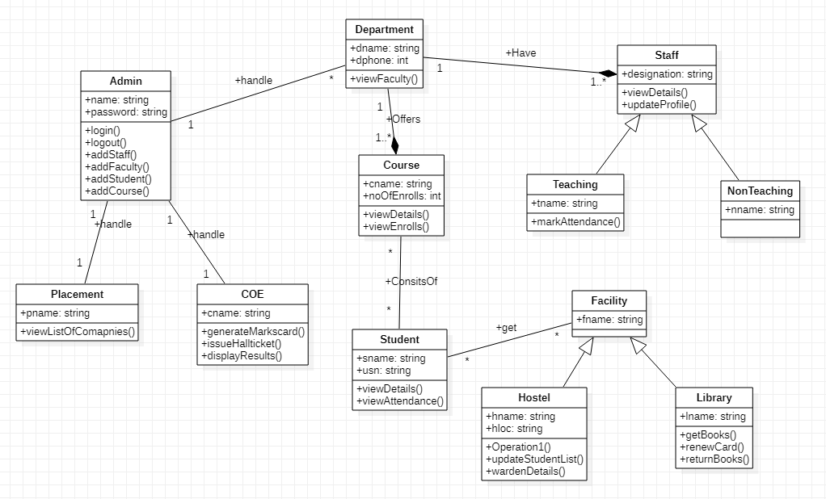

Admin can view and modify the student’s records, teachers and department details.The students of the college register themselves in the department and examination and for the courses they are interested in and join the college by taking admission and following all the admission procedures.College conducts Internals and semester end examination for students.

**1.4 State Diagram**

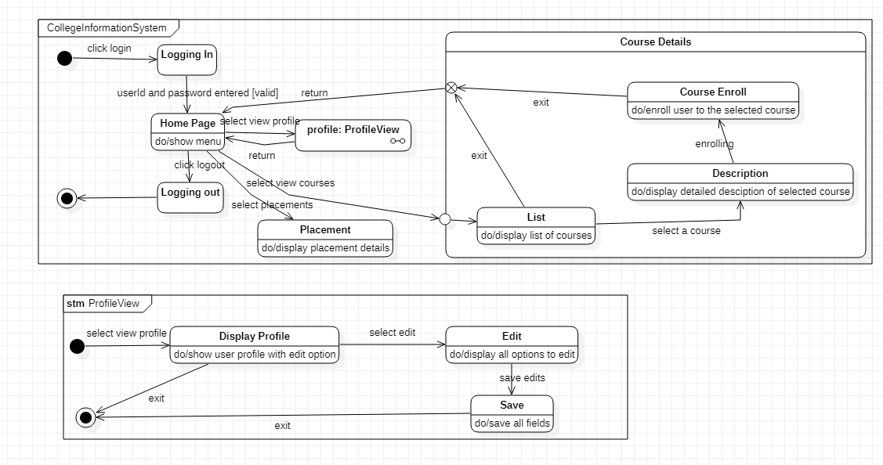

The above state diagram describes the states the admin goes though in uploading information of student,staff and department. The admin first needs to login which then leads to the validate state,where the login id and password are validated. If invalid it then goes back to the login state or goes to the get information state. Upon receiving the correct information it goes to the upload state and then to commit state to save all changes. The admin first needs to login and be cleared of their permissions. The admin can then manage information related to the student,teacher,or department.After necessary changes the admin can update the information and logout from the system.

## **2. HOSTEL MANAGEMENT SYSTEM**

### **2.1 Problem statement**

The purpose of Hostel Management System is to carry out different operations of a hostel. This system will provide ease, comfort of use to the staff of the hostel by performing all work on computer. It helps to manage student and staff records.

### **2.2 Software Requirement Specification**

* Admin can login using credentials provided to him.
* Admin can allot room to students.
* Students can login using the credential provided and can give feedback about staff.
* Admin can review the feedback provided by students.
* Admin can appoint staff.
* Students can provide mess feedback.
* Mess managers can review the mess feedback.
* Mess manager can update the menulist.
* Admin can assign work to staff members.
* The system should be easy to handle.
* System should give expected performance results.
* The response time should be small..

### **2.3 Class Diagram**

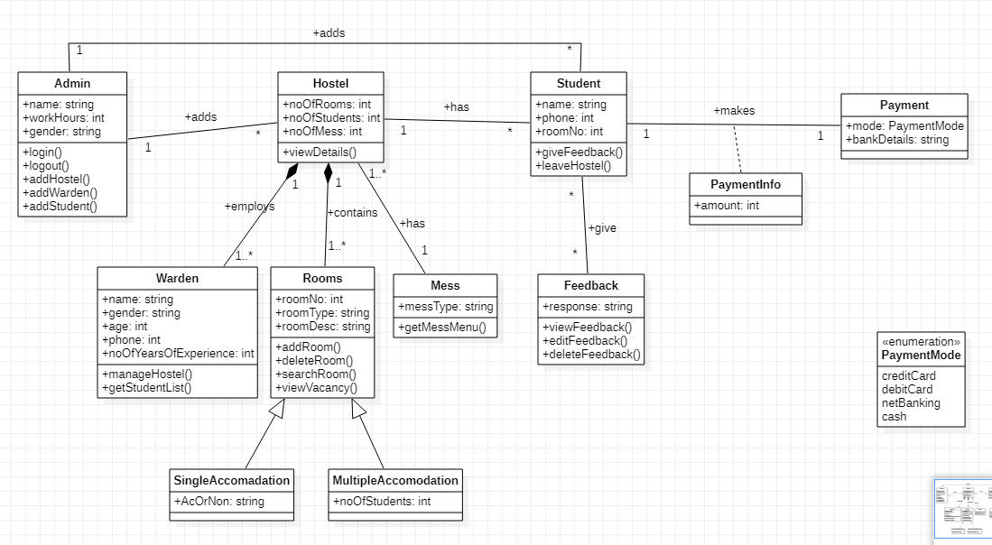

Hostel management system has admin who manages the hostel,allot-es and payment methods.The allot-es makes payment according to the bill generated which have the attributes bill number,type and date.The hostel is categorized into two types I.e boys and girls hostel.A hostel is made up of mess and rooms.A mess account will also generate. This account having the mess status of the whole month.

**1.4 State Diagram**

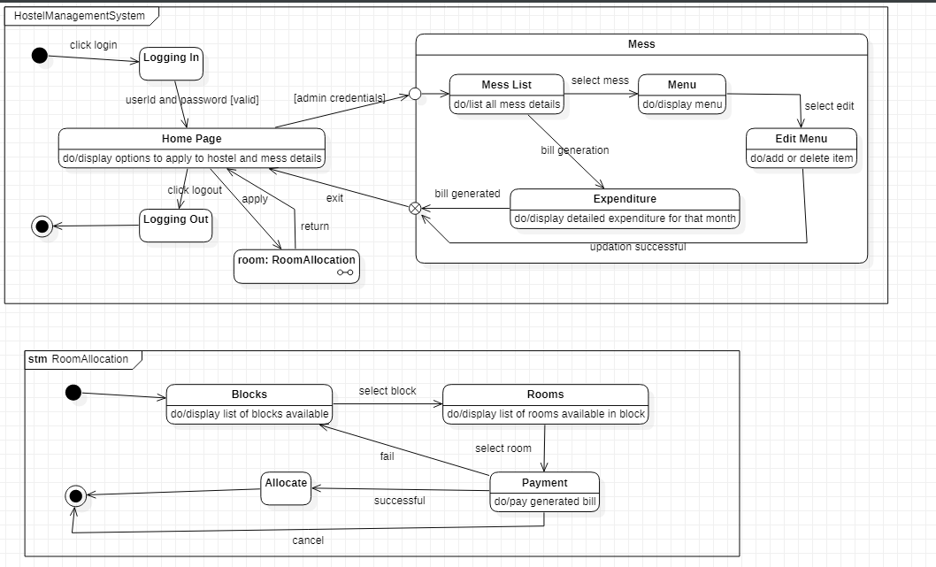

The above state diagram gives the movement of states in allotting a room to a student. The admin allots rooms for students. The admin first login s to the database ,which displays a set of

options.the admin then chooses to allot rooms and finds the availability for rooms. If rooms are available then the admin allots room to the student and when successful the student makes the payment. If no rooms are available,a message is displayed and control goes back to the display state.

## **3. STOCK MAINTENANCE SYSTEM**

### **3.1 Problem statement**

The stock maintenance system will allow the employees to record information of the items available in the store and generate reports based on the total amount of sales. The new system will have a windows-based desktop interface to allow employees to enter the information of sales, purchase orders, change employee preferences and create reports. The system retains information on all the items in the shop. The system retains the records of the cost, expiry date, vendor details, Discount, quantity. The employee maintains the information of the sale of the item. He can add the items at the right time and update the database. The customer can view the availability of the required items and the price of the items. The customer can just view them but cannot make any changes

### **3.2 Software Requirement Specification**

* The customer logs in to the particular site.
* They fill the customer details.
* They place the orders for their product.
* The vendor logs in and views the customer details and orders

### **3.3 Class Diagram**

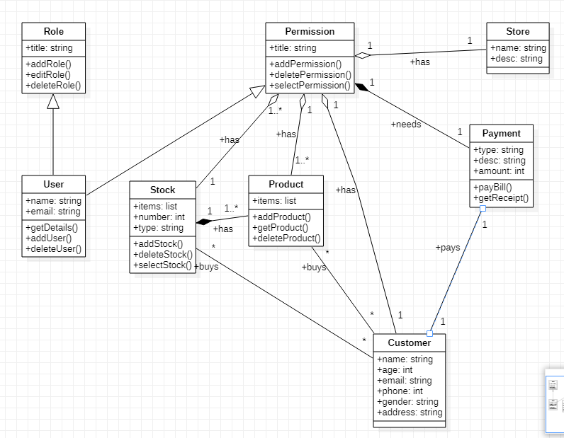

The products are displayed in stores across the city or world. All the information regarding the store are used to locate any product.The stores can be of many types.Some of them are departmental stores,super markets and ware houses where the products are kept for display.The vendor deals with the information about the details of the suppliers giving product to the organization.The stock of the products is maintained separately.The stock deals with information about the details of the product that the concern handling.

**3.4 State Diagram**

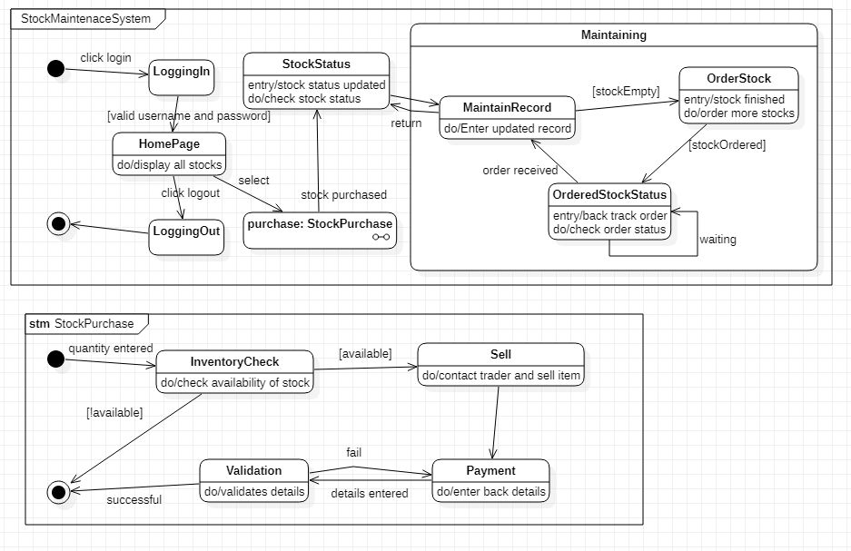

The state diagram above gives us the states involved in purchasing an product and placing the order for the same. There is first an inventory check ,where is stock of products is noted and if the stock is less than minimum an order is placed by first searching for suitable trader . if a suitable trader is found , the order is placed and verified by the accountant. After the accountant has verified a payment is made for the products purchased.

## **4. COFFEE VENDING MACHINE**

### **4.1 Problem statement**

The Objective of the system is to prepare a coffee vending machine for commercial purpose. The system will be able to prepare coffee by processing all its required ingredients. Users will be provided with sophisticated and easy to use user interfaces.

There are many different types of coffee makers using a number of different brewing principles, in the most common devices, coffee grounds are placed in a paper or metal filter inside a funnel, which is set over a glass or ceramic coffee pot, a cooking pot in the kettle family. Cold water is poured into a separate chamber, which is then heated up to the boiling point, and directed into the funnel.

### **4.2 Software Requirement Specification**

* The vending machine must have money box, coin slot, display screen and products i.e coffee for the machine to be used.
* The user on selecting a coffee ,the coffee machine must be able to dispense the selected coffee to the user.
* The user shall get empty cup placed right below the filter.The user shall be able to choose his preferred beverage from the list of options(buttons).
* There must be buttons(start,pause,stop,coffee,tea,milk) for user to interact with the system.
* The user shall be able to purchase one kind of available drink at a time and get back the exact changes if he has put extra money. The user shall be able to quit the dispense of any beverage at any time during the dispensing.
* The system(machine) shall check for properly inserted coins.
* The system shall be able to dispense coffee(or selected beverage) after a coin has been inserted.
* The system must accept coins of different amount and the system must compare the item cost with entered coin.
* The system must check the validity of coins.
* The system shall be able to detect the low amount of ingredients and low number of cups and indicate with an indicator(small LED).

### **4.3 Class Diagram**

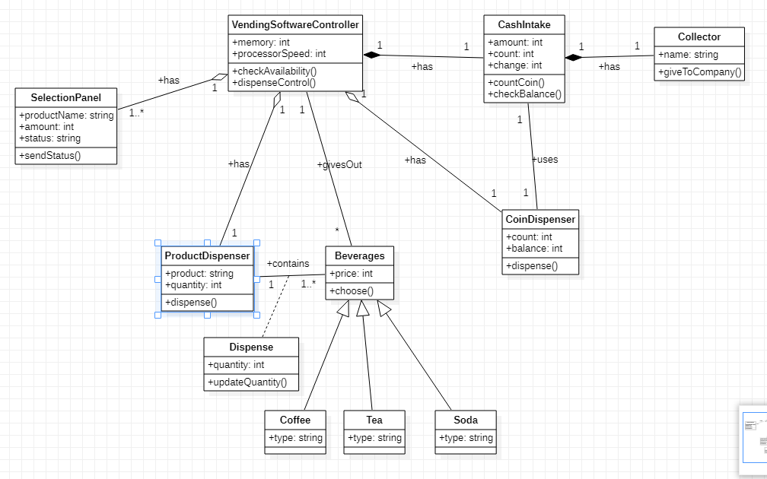

The vending machine must have money box, coin slot, display screen and products i.e coffee for the machine to be used.The user on selecting a coffee ,the coffee machine must be able to dispense the selected coffee to the user. The user shall get empty cup placed right below the filter.The user shall be able to choose his preferred beverage from the list of options.There are different types of coffee such as cappuccino,black coffee,cold coffee and latte. Each type of coffee has a price and a name. A customer can buy their choice of coffee by selecting the button of their coffee and paying for the same through the coin box.

**4.4 State Diagram**

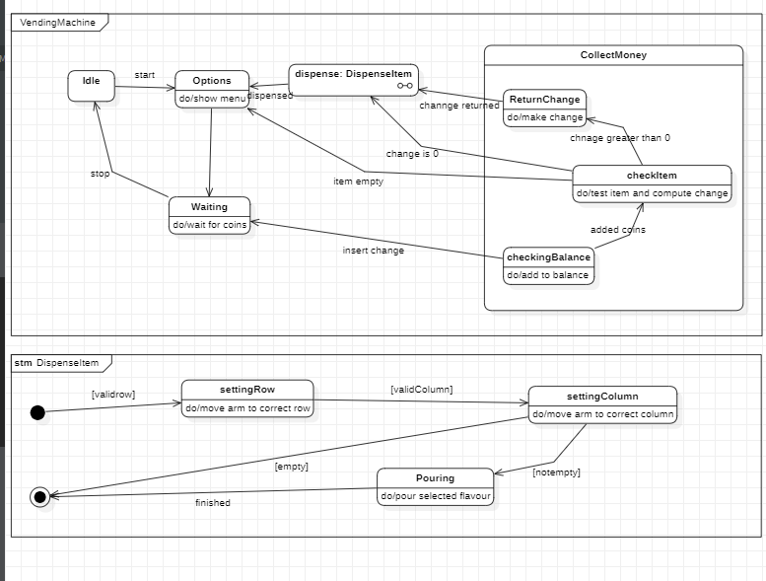

Initially the vending machine is in the waiting state. The machine displays the selected item selected by the user. When the person inserts a coin the machine adds the amount to he cumulative balance. After adding some coins, a person can select nay item. If item is empty or balance is insufficient,the machine waits for another selection. Otherwise the machine dispense the item and returnsthe appropriate change.

The state diagram for coffee vending machine has a submachine called dispense Item ,which has the states for dispensing an item from the vending machine.the arm of the machine first moves to an appropriate row,when ready,moves to an appropriate column and when the arm is ready it finally dispences the item from the machine.

## **5. ONLINE SHOPPING SYSTEM**

### **5.1 Problem statement**

The Online Shopping System for all kind of products web application is intended to provide complete solutions for vendors as well as customers through a single get way using the internet. It will enable vendors to setup online shops, customer to browse through the shop and purchase them online without having to visit the shop physically. The administration module will enable a system administrator to approve and reject requests for new shops and maintain various lists of shop category.This system allows the customer’s to maintain their cart for add or remove the product over the internet.

### **5.2 Software Requirement Specification**

* The customer must have an account in the online website where he/she can purchase products.
* If customer wants to buy the product then he/she must be registered, unregistered user can’t go to the shopping cart.
* Customer login to the system by entering valid user id and password for the shopping.
* Changes to cart means the customer after login or registration can make order or cancel order of the product from the shopping cart.
* The products sold for customers are sold for various categories like men,women,kids and home products.
* Customers can view all available products ,compare them and make a choice for purchasing the products.
* For customer there are many type of secure billing will be prepaid as debit or credit card, post paid as after shipping, check or bank draft. The security will provide by the third party like Pay-Pal etc.
* After the payment or surf the product the customer will logged out.

### **5.3 Class Diagram**

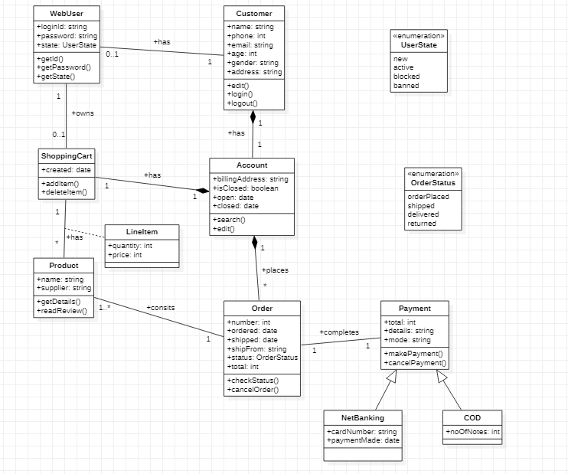

The online shopping system has customers who must have an account in the online website where he/she can purchase products.If customer wants to buy the product then he/she must be registered, unregistered user can’t go to the shopping cart.Customer login to the system by entering valid user id and password for the shopping.The products sold for customers are sold for various categories like men,women,kids and home products.After the payment or surf the product the customer will logged out.

**5.4 State Diagram**

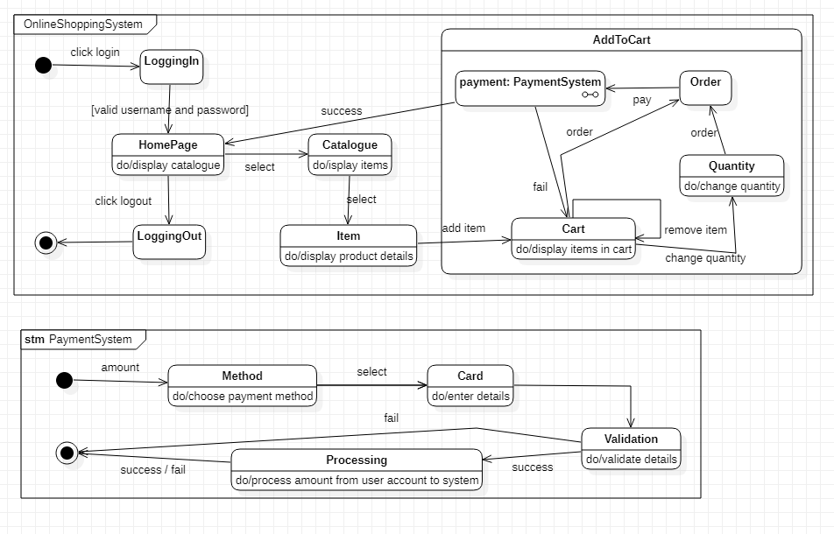

The advanced state chart diagram has states explaining the product purchase and payment. It has two sub machines i.e product selection and checkout product. Product selection allows us to select products and add them to cart. Checkout product has states explaining the payment methods and validating the methods.

## **6. RAILWAY RESERVATION SYSTEM**

### **6.1 Problem statement**

To develop a user-friendly Railway Reservation System to enable passengers to book tickets online and make payment online as well.

### **6.2 Software Requirement Specification**

Railway reservation system project which provides the train timing details, reservation, billing and cancellation on various types of reservation namely, • Confirm Reservation for Seat.

• Reservation against Cancellation.

• Waiting list Reservation. • Online Reservation.

• Tatkal Reservation

This system enables the Advance booking in any class, against general and ladies quota, on payment of fare in full for adults and children, a maximum of six berths/seats at a time, for journey between any two stations served by a train.

It also provides details about

1. Timetable

2. Train Fares

3. Current status of reservation position

4. Train available between a pair of stations

5. Accommodation available for a train/date combination Types of tickets: General and Tatkaal

### **6.3 Class Diagram**

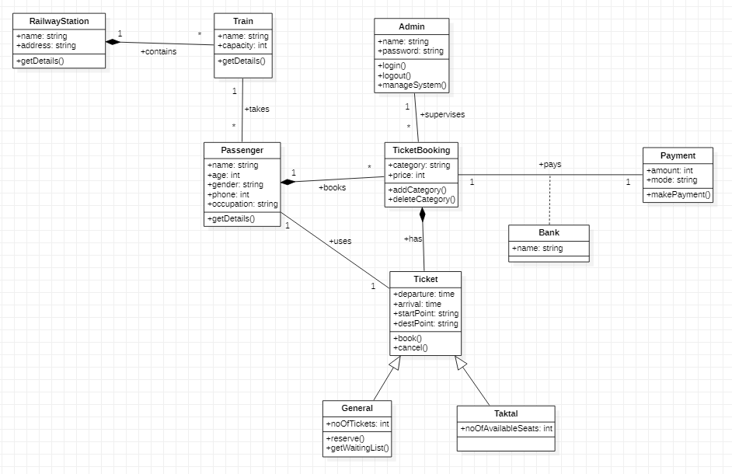

The admin manages the trains and reservation related to railway reservation system. There are three types of reservation, I.e RAC,waiting and confirmed.The passengers with a reservation goes to one or the other reservation.A train consists of coaches and engine.A passenger pays for the ticket booked .Tickets can be booked in two ways by i-ticket or by e-ticket booking.

**6.4 State Diagram**

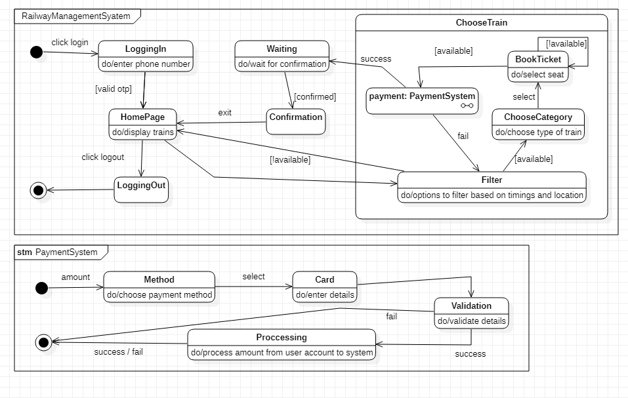

The advanced state diagram has states for paying the ticket.from the ready state the user goes to payment initiation after which the card details are accepted and an OTP is sent to the registered mobile number. On verification the money is deducted and ticket is sent to the customer.

## **7. GRAPHICS EDITOR**

### **7.1 Problem statement**

The graphics editor provides an Application Programmer’s Interface that enables a programmer to develop their own graphical model editor for a specific type of model.

This API in turn, relies on extending the Eclipse Graphical Editing

Framework to provide an environment in which the editor functions, and the programmer can create a graphical editor and palette of shapes in order to

modify an underlying model.

The graphical editor provides an interface with which the programmer implements the said editor for a given underlying model. Such an instance of the graphical editor allows a user to drag objects from a specified model into a working graphical diagram.

### **7.2 Software Requirement Specification**

* It contains the toolbox which contains tools like: Line, Circle, Rectangle, Arc,  
  Text, Draw, Eraser.
* Color box or palette.
* Standard toolbar with options for New, Open, Save, Toolbox and Text Toolbox.
* One integrated view to users for toolbar, color box, menu, and graphic screen.
* Easy handling of tools for users.
* Ability to group several drawings into one i.e. complex drawing.
* Provision of zoom in and zoom out.
* Different shadings of line tool are provided.

### **7.3 Class Diagram**

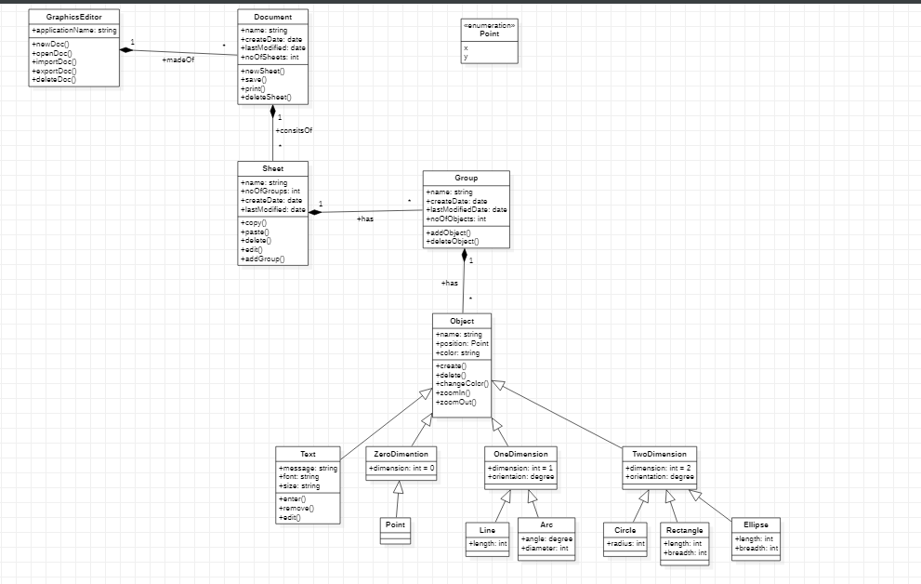

The graphical editor has documents consisting of several sheets. Each sheet contains drawing objects, including text, geometrical objects and groups. A group is simply a set of drawing objects. A geometrical object includes circle, ellipse, rectangles, lines and squares.

**7.4 State Diagram**

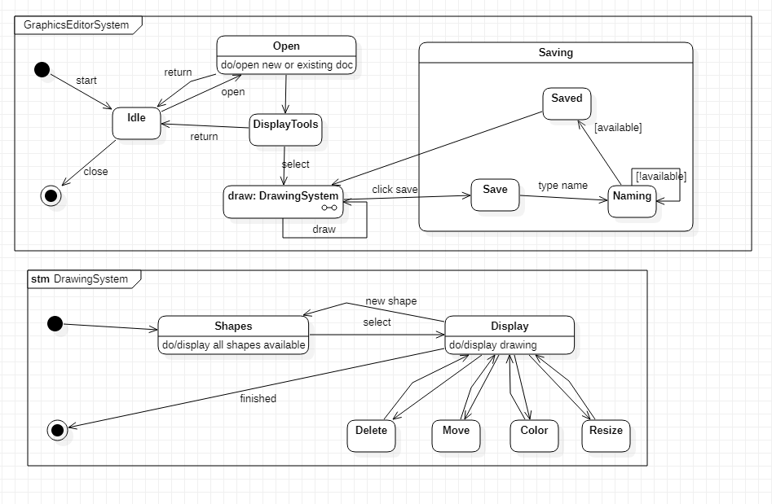

The advanced state diagram gives the states involved in making and saving a graphic file.first the user selects a new document and draws graphics. If there is a mistake he can erase and select a color from the color palet. He can then save the file created.

The advanced state diagram had a composite state called saving where the user can save the file in their desired location.